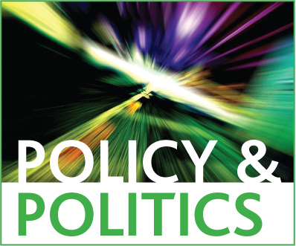

Policy & Politics Special Issue Marketing Questionnaire

Our experience shows that input from guest editors and authors is crucial to the success of our special issues. You are usually in the best position to advise us of the main interest groups and networks who will be interested in your issue, and of the main influencers who can really help us to promote your ideas. Ideally your suggestions should be as international as possible so please do consult your authors to tap into their networks before returning this form or give us permission to approach them.
Please return to our Journal Manager at sarah.brown@bristol.ac.uk

Title of Special Issue:………………………………………………………………………………..
Name of corresponding guest editor:…………………………………………………………….

E-mail marketing
Please give details of any networks whose members would be interested in your Special Issue, specifically:
- research networks/email groups/
- listservs/jiscmail groups
- special interest group/standing group convenors.

Publications

Please list up to 6 key journals, newsletters or professional magazines that are likely to be interested in reviewing your Special Issue.

Conferences
- Please list the 3 most important conferences which your Special Issue is relevant for.

Organisations and Associations
Please list the following whose members would be interested in your Special Issue:
- professional organisations
- professional networks
- societies
- government bodies
Are there any particular universities and/or research centres we should target with your Special Issue?

Websites and Social Media
Please ensure that you send us a blog for each article in your Special Issue at least 2 weeks before publication.
Please ensure that we have twitter handle(s) for all authors and editors at least 2 weeks before publication.
- Please list the top five influencers on Twitter who will be interested in your Special Issue
- Please list the main blogs most relevant for your Special Issue.

PR
- Are there any particular articles in your Special Issue which are particularly newsworthy or topical?

Other information
- Do you have any other information that may be useful for promotional purposes?

